
November 28, 2014 – today the temperature was in the 30’s, and we had snow last night; in 2005 we had to contend with 70-degree weather. Oh, today is “Black Friday”, which has become a non-day as the sales started two weeks ago, thanks to the many Media forms today.

We hope you had a great Thanksgiving with family and/or friends; I know ours was just grand!

I know…I know. You have all been waiting for me to let you know that this is our 12th wedding anniversary. Where did the time go? Donna has constantly let me know how special I am and of course, I agree! They say to always agree with your spouse and I can’t let anyone down now, can I? She just keeps getting better and better as time goes by.

We pray that those of you who have had losses and setbacks get back on your feet and enjoy your lives again.
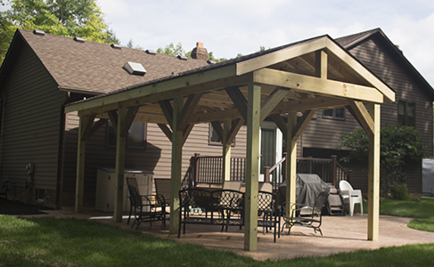
This summer saw us hosting "The Great Cousins’ Party" and with such an endeavor on the horizon, we commenced to replace the old deck and patio with a new deck, patio & pavilion. The patio and deck were completed but the pavilion did not make it. Abree (our 7 yr. old grand-daughter) decided to go out after the cement was poured, finished, and everyone was in the house for the day, to stamp her mark in the fresh cement. Ughhhhh! The patio is stamped concrete, literally! Now we just laugh about it. The deck was completed that morning a couple of hours before the party started. Very close call! Cousins came from far and wide to marvel at the “great depression” works projects, and of course to enjoy the company of all that were present. The pavilion is now completed and it all looks great. It’s like being in the park! The grand kids from Dallas were here and they managed to bring their parents for the event. They kept everyone busy with racing around the yard with the ride-in electric cars found at our neighbors, who also kept them pretty busy with their grandkids.

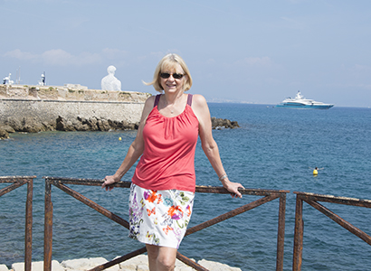
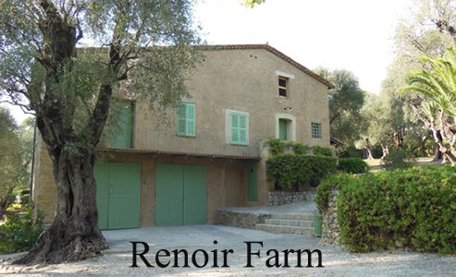
Our latest trip, at the end of August, was to Antibes, France (Picasso lived there), where we rented a newly refurbished 3rd floor walk-up apartment in the center of the town. Antibes is near Nice, along the Côte d’Azur. The area has many interesting museums and attractions for the traveler. Visiting the Molinard perfume manufacturer; Huilèrie de Sainte Anne, an olive mill; the Picasso Museum; and the home and working farm of Renoir (now a museum); we found the area interesting and fun. We drove to Italy and found the Fratelli olive mill and purchased a couple of bottles of olive oil to bring home. Renting a boat, we navigated the coast for about 3 hours checking out the multi-million dollar/euro yachts and the sunny beaches. Some towns we visited were Nice, Monaco, Menton, Grasse, Biot, Canne, and Eze. Each has/is an interesting site, from a medieval village to the Monte Carlo Casino. Visit our web site for a photo-video of the trip.

My son Ben, his wife Robin, and the kids are living the adventures they always dreamed of, in Washington State.

This is the first semester in nine years, in which I did not take a course at the university. No, my brain is not full. I just had to change priorities with the construction and trip. So, now I spend some time at the “Y” a couple days a week and have a trainer who can’t believe I am not enthusiastic about exercise. I keep telling him, “I’m here because I need to exercise not because I want to exercise”. He’s okay with my griping because I make him laugh at my antics (they are yelps and ouches from the pain).

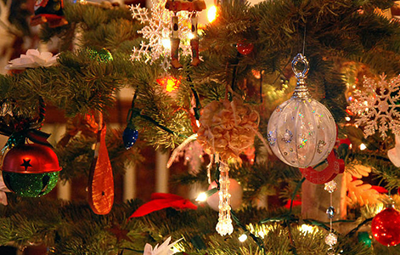
Christmas Memories: The real XMAS trees, in the 50’s, freshly cut, really had a strong smell of pine, which permeated our house. The tree usually fell over at least once during the holiday season. The light bulb colors were bold and bright, not like the itty-bitty lights we have today. The needles usually started to fall out, right around Christmas, due to all the heat from the lights. When you walked around the tree you had to be careful you did not step on the needles (Ouch!). Do you remember the candy your grandmother gave you at Christmas, the ribbon candy, the candy canes, and the peeps from Easter? Just kidding! I can remember going ice-skating out doors in the park across from St. Sebastian’s Church (Akron). They don’t do that there anymore.


Well, our fireplace is hot, I have a nice warm drink, my honey is here beside me and the music is playing soft and low. What more could you want. Hmmm, "Honey, can I have a sandwich? And don’t forget the pickles!"

To you, our family, our friends, with our love, respect and admiration, we wish you a wonderful holiday season and a happy, healthy, New Year! So, until next year…we wish you and yours the very best life can offer.

Ben & Donna Visit our regular web site at: www.nls.net/mp/blqt

